TEAM YELLOW
Project Manager: Toni Katanušić
Front End Lead: Mihovil Medak
Back End Lead: Domagoj Dušić
Database Administrator Lead: Samuel Spence
General Backup Lead: Ejup Elezi
Full Stack Lead: Franko Fišter

User Documentation
Network Activity
20.04.2026.

Contents
Introduction 3
Sign in 4
Create Account 5
Password Reset 6
Navigation Menu 7
Dashboard 8
Explorer 9
Top Hotspots 10
Clusters 11
Reports 12
Labels 13
Transaction Flow Visualization 15
Risk Monitoring Dashboard 16
Settings 17
General User Guide 18

Introduction
This document serves as a comprehensive user guide for the Blockchain Analytics (Network Activity) system. The purpose of this document is to provide users with a clear and structured understanding of how to navigate and utilize the application.
The system is designed to monitor blockchain transactions, analyze network activity, visualize transaction flows, detect anomalies, and manage labeled blockchain entities such as wallets, exchanges, and smart contracts.
This guide explains the functionality of each page within the system, the features available to users, and the general workflow required to accomplish common tasks. It is intended for all users interacting with the system, regardless of their level of experience.

Sign in
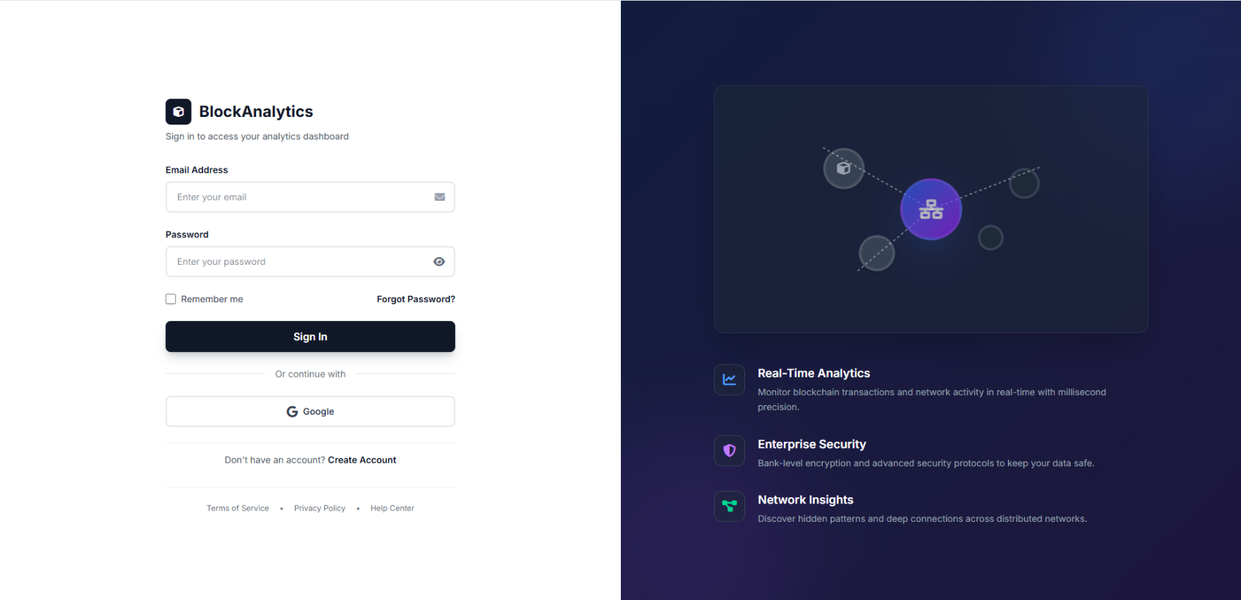
The Sign In page allows existing users to access the system.

Respective Content
Email and password input fields, remember me checkbox, Google login option, and password recovery link.

Access Level Needed
All registered users.

Functionality Provided
Users authenticate using credentials or Google login. Successful login redirects to the Dashboard. Failed attempts require re-entry of credentials.

Create Account
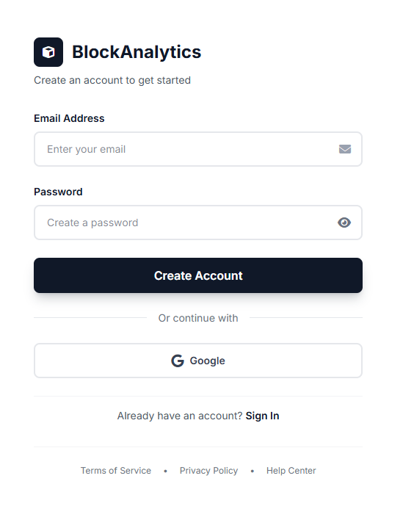
The Create Account page allows new users to register.

Respective Content
Email and password fields with account creation button and Google sign-up option.

Access Level Needed
Public (no prior authentication required).

Functionality Provided
Users can create new accounts and immediately gain access to the system.

Password Reset
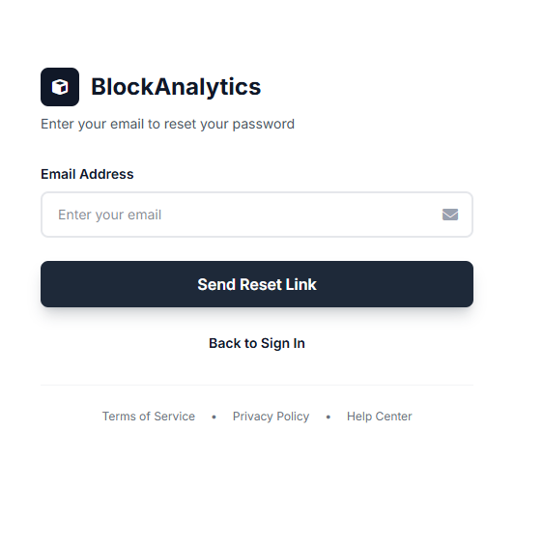
Allow users to recover access to their account.

Respective Content
Email input and reset link button.

Access Level Needed
Public.

Functionality Provided
System sends reset instructions via email.

Navigation Menu
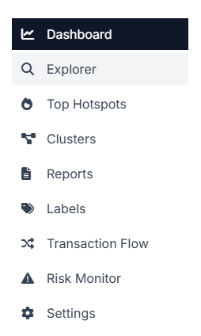
The sidebar navigation allows users to move between all pages of the system.

Respective Content
Dashboard, Explorer, Top Hotspots, Clusters, Reports, Labels, Transaction Flow, Risk Monitor, Settings.

Access Level Needed
All authenticated users.

Functionality Provided
Provides consistent navigation across all pages.

Dashboard
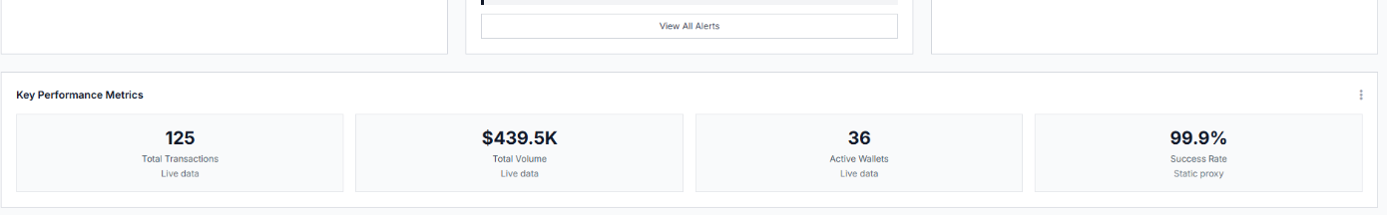
The Dashboard is the main overview page displaying real-time blockchain analytics.
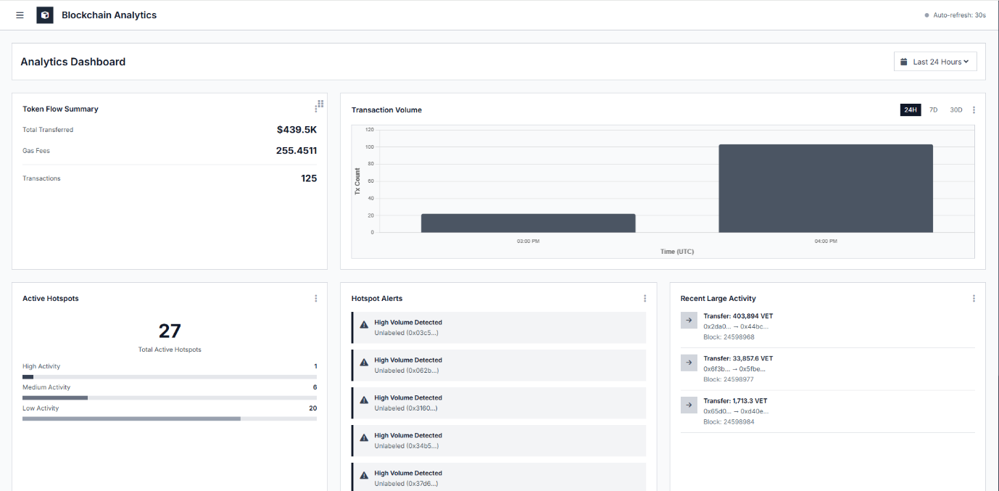
Respective Content
Token flow summary, transaction volume charts, hotspots, alerts, recent activity, and performance metrics.

Access Level Needed
All authenticated users.

Functionality Provided
Users can monitor network activity, identify trends, and detect anomalies quickly.

Explorer
The Explorer page allows searching blockchain data.
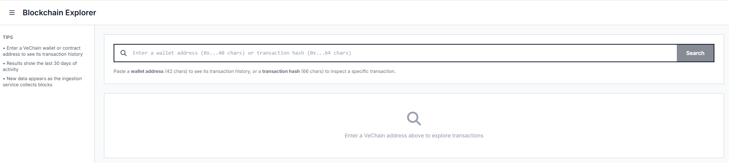

Respective Content
Search bar and input instructions.

Access Level Needed
All authenticated users.

Functionality Provided
Users can view transaction history and inspect specific transactions.

Top Hotspots
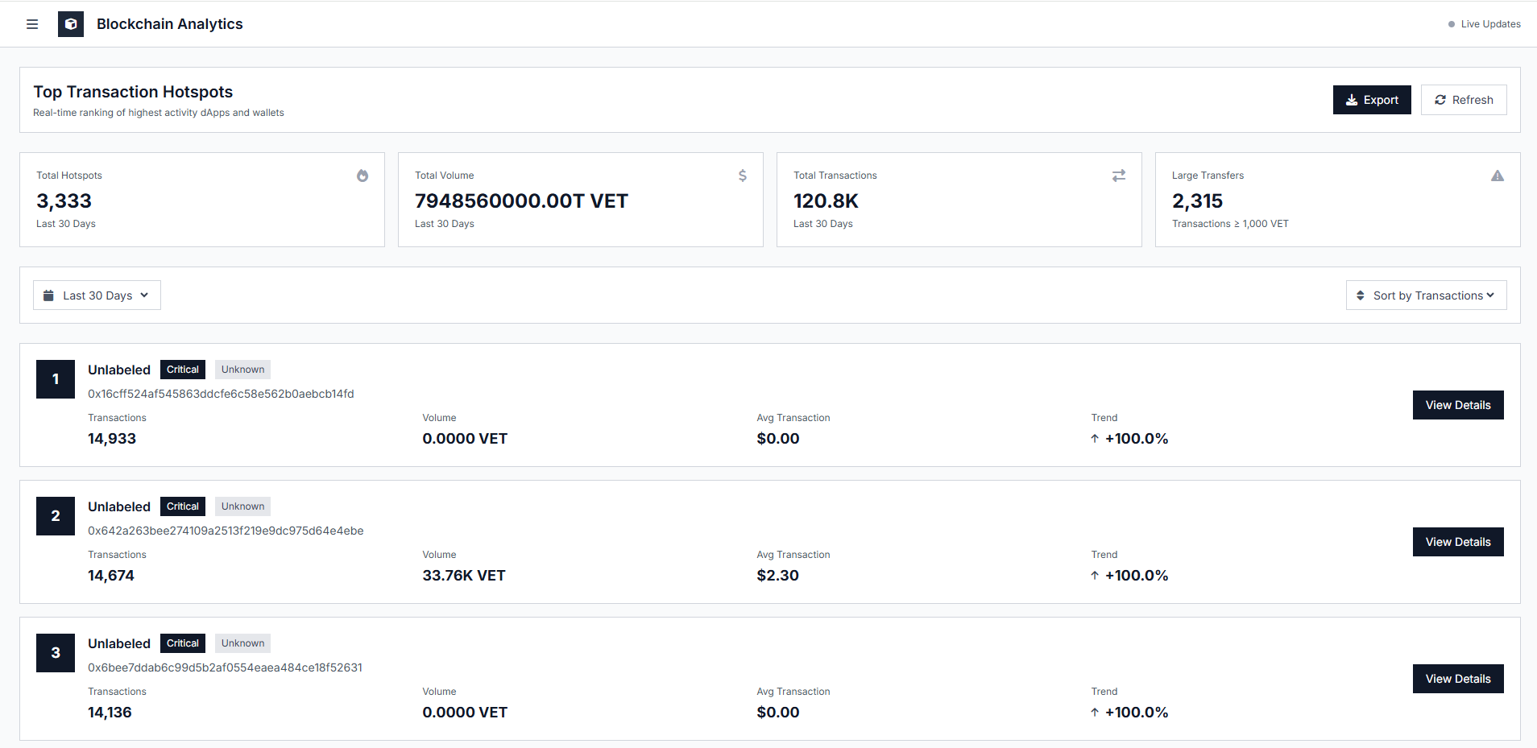
Displays high activity areas.

Respective Content
List of active hotspots categorized by activity level.

Access Level Needed
All authenticated users.

Functionality Provided
Helps identify high-volume areas.

Clusters
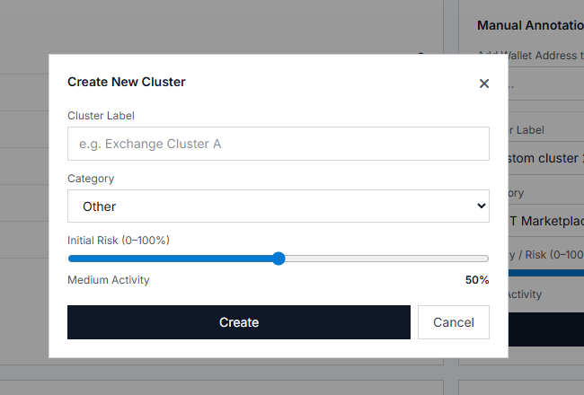
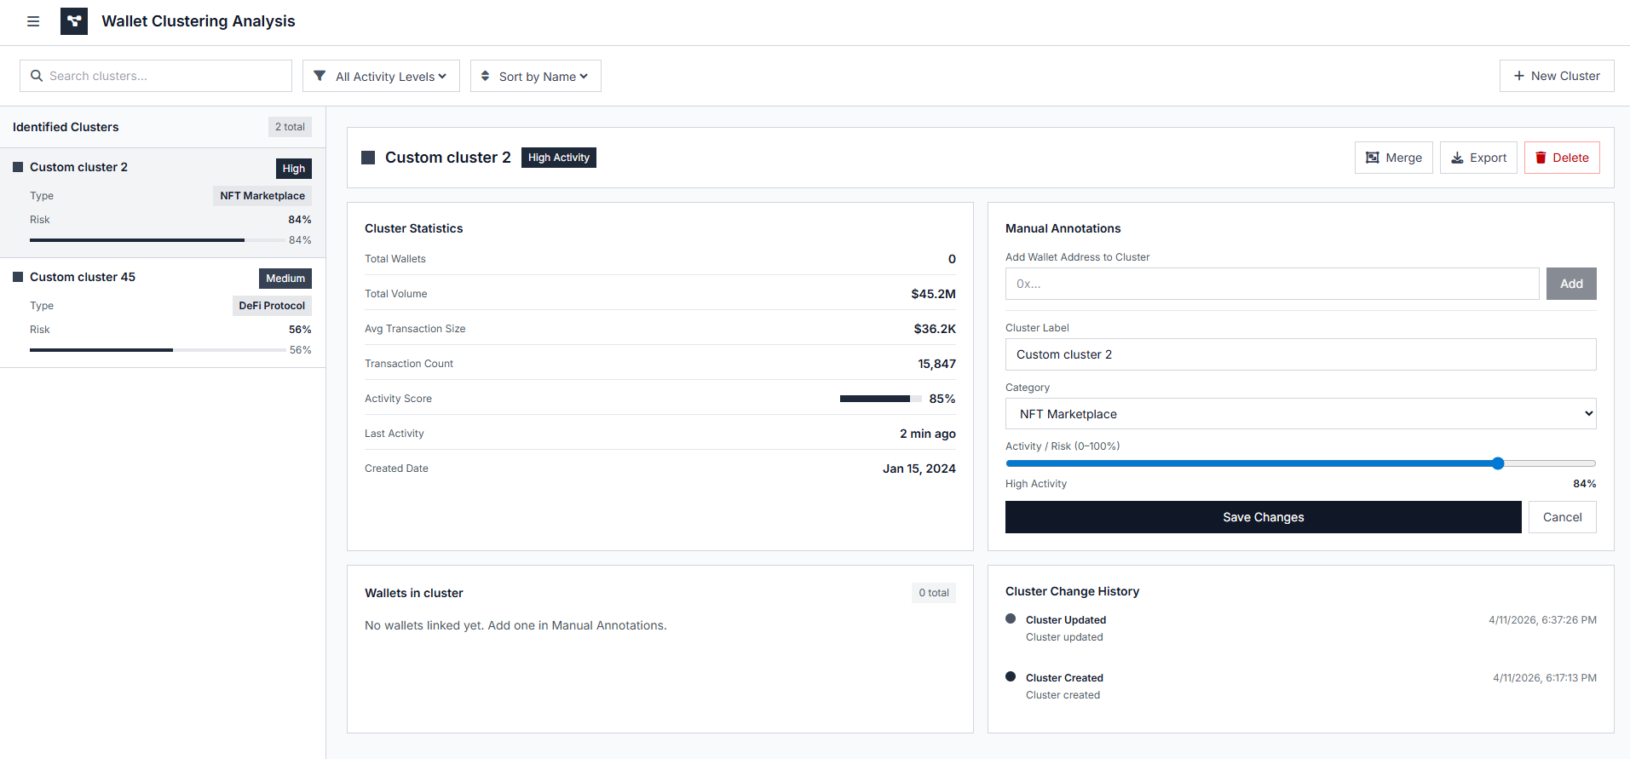
Groups related wallets for analysis.

Respective Content
Cluster list, statistics, annotations, and history.

Access Level Needed
All authenticated users (editing restricted to authorized users).

Functionality Provided
Users can create clusters, assign risk levels, and manage data.

Reports
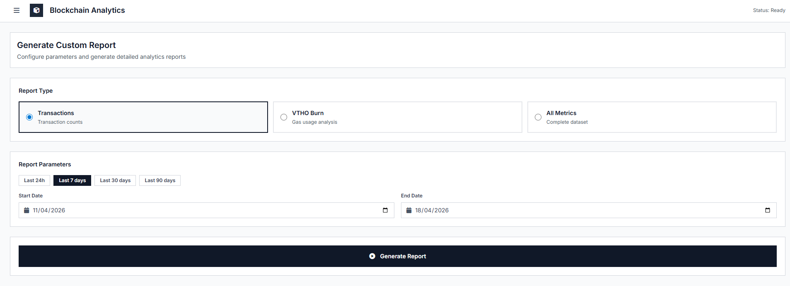
Generate analytical reports.

Respective Content
Report type selection and date filters.

Access Level Needed
All authenticated users.

Functionality Provided
Users generate reports for analysis.

Labels
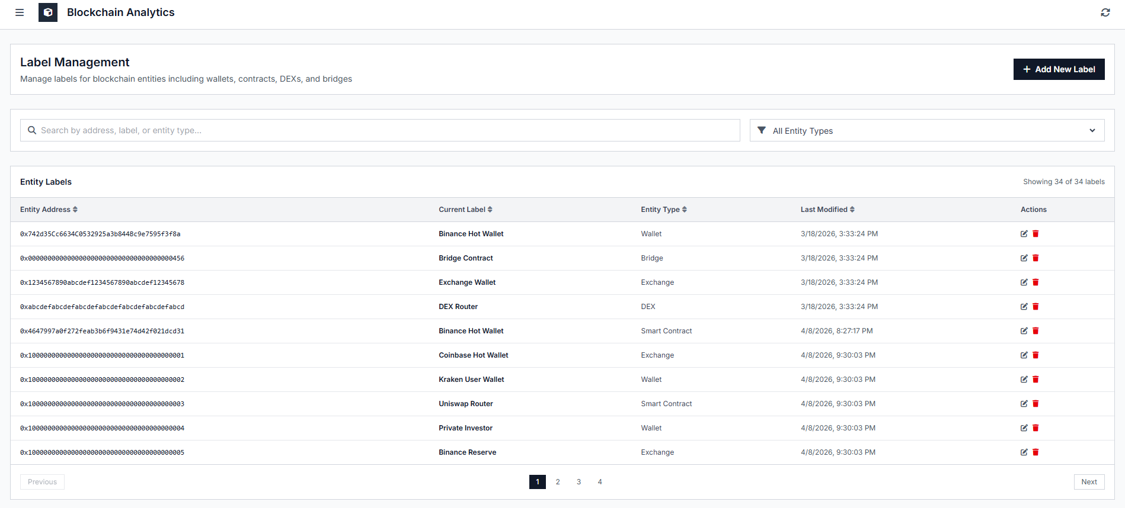
Manages blockchain entity labels.

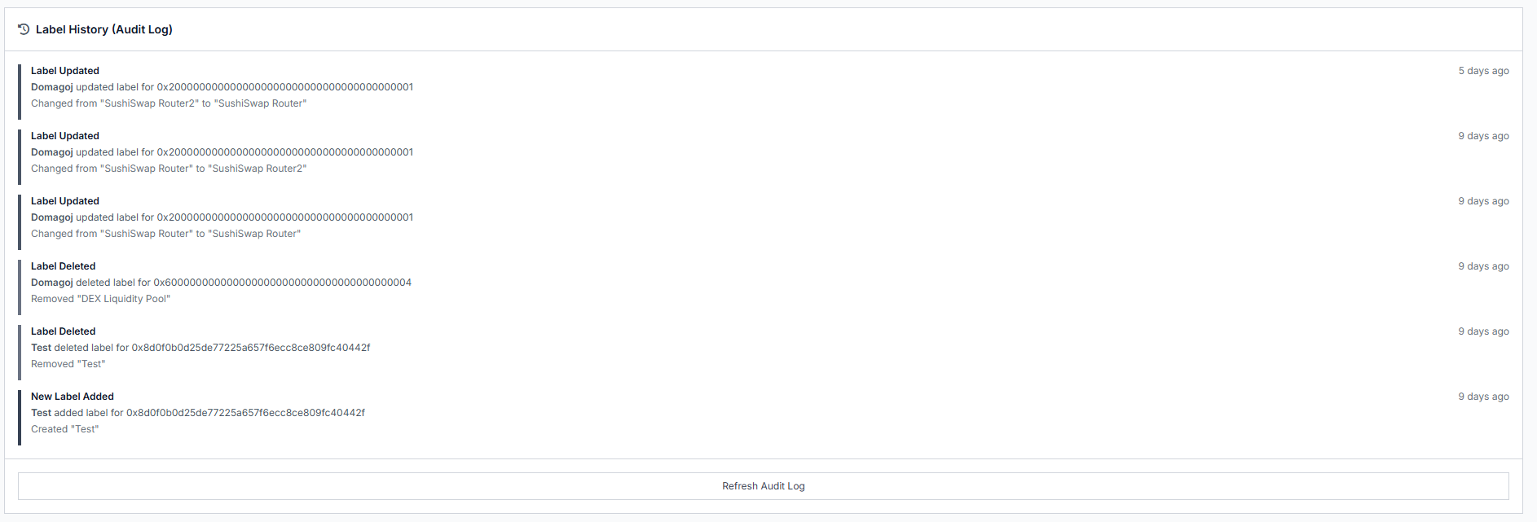

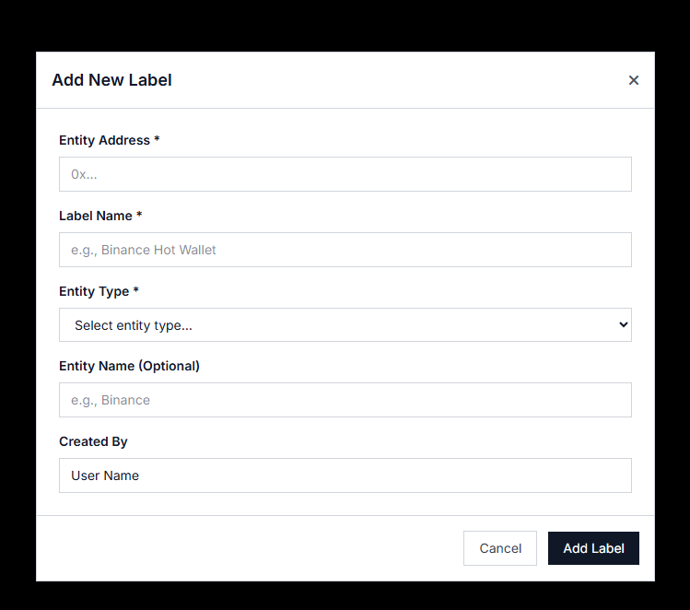

Respective Content
Table of labeled entities with search and filter options.

Access Level Needed
All authenticated users (editing restricted).

Functionality Provided
Users create, update, delete, and track labels.

Transaction Flow Visualization
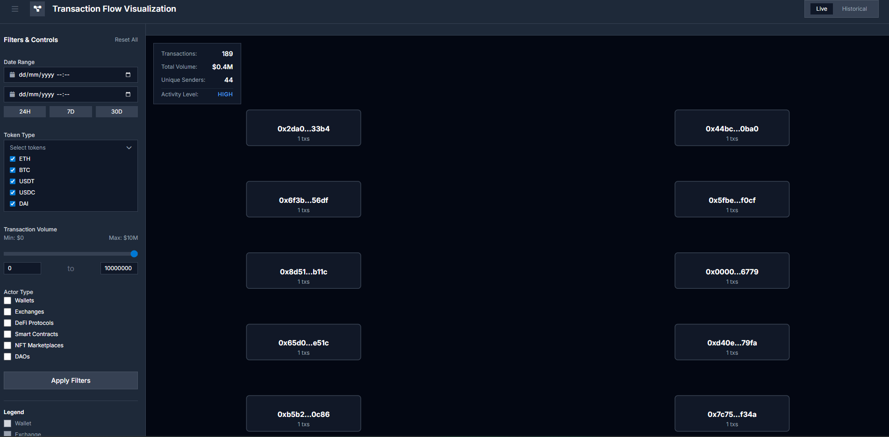
Visualizes transaction relationships.

Respective Content
Graph view with filters and metrics.

Access Level Needed
All authenticated users.

Functionality Provided
Users analyze transaction flows and relationships.

Risk Monitoring Dashboard
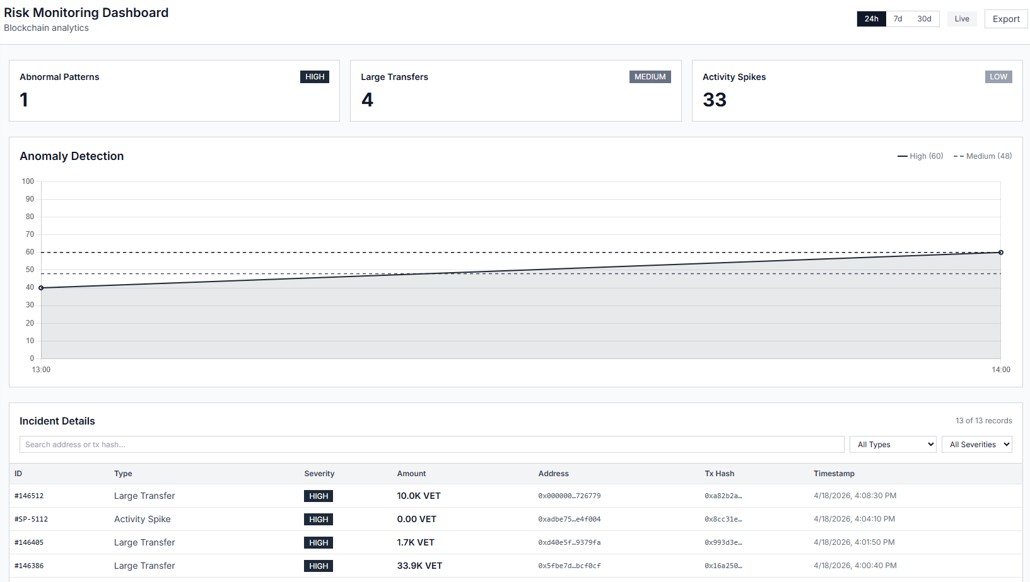
Detects abnormal activity.

Respective Content
Anomaly charts and incident table.

Access Level Needed
All authenticated users.

Functionality Provided
Users monitor risk and investigate incidents.

Settings
Allows account management.
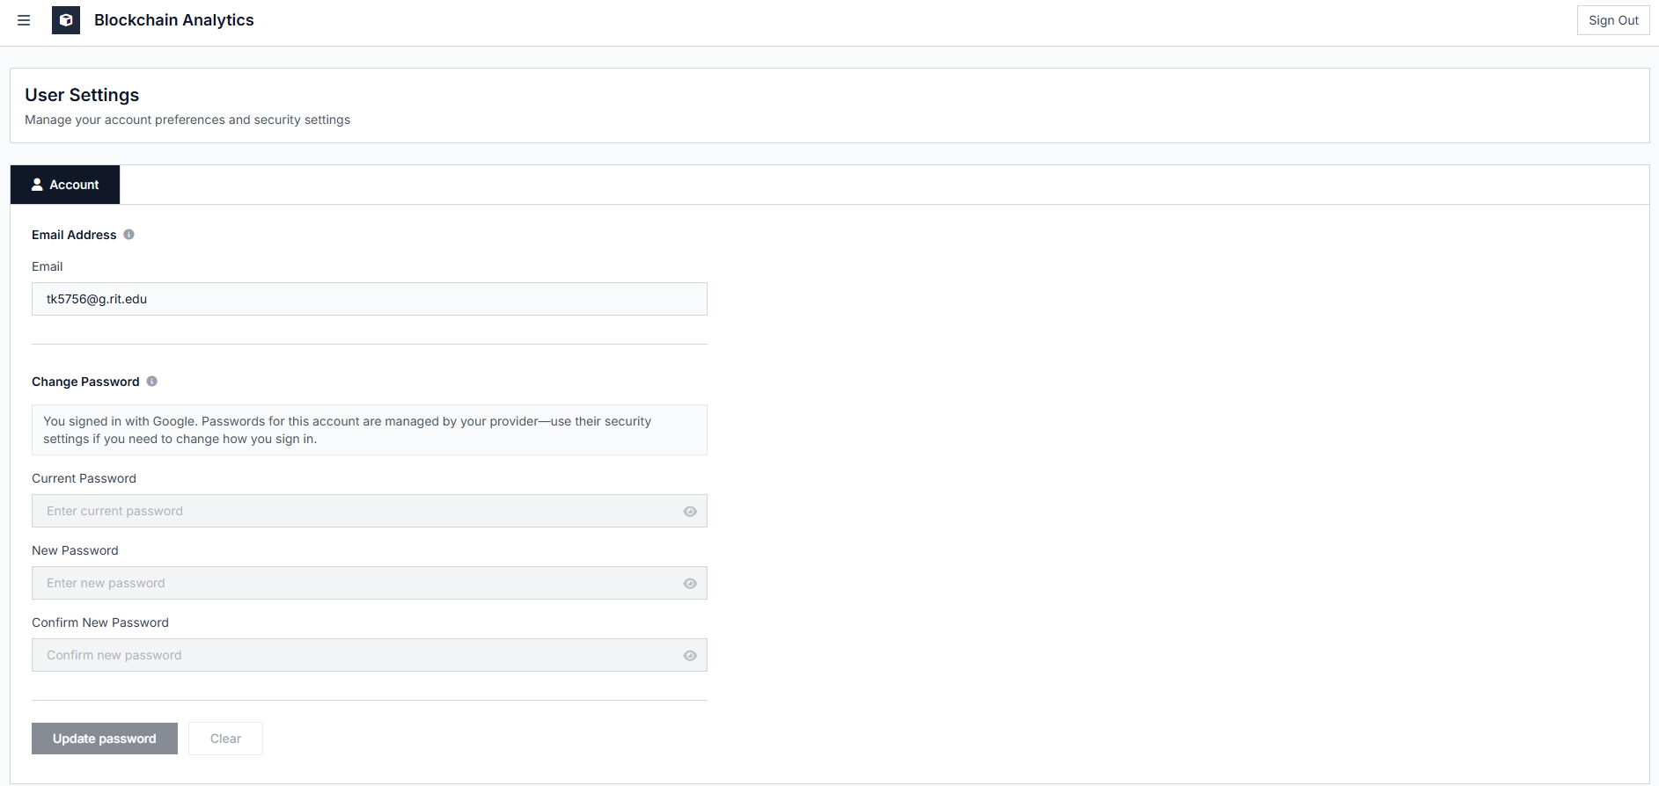

Respective Content
Email display and password update fields.

Access Level Needed
All authenticated users.

Functionality Provided
Users update account information.

General User Guide
Users log in, view dashboard, and navigate through sections to analyze data, manage entities, and generate reports.
The system supports monitoring, analysis, reporting, and risk detection.

